Vol.2. Issue 1 May, 2013

Editorial

With the dawn of new year , new resolutions are made. This dawn heralds new spirit and enthusiasm which propels us to move further and inch towards our goals. It is also the time to retrospect as to what we intended to achieve and what we have achieved. Let us all resolve to set and achieve higher targets in the coming year. We at college level were witness to and were a part of plethora of activities that will shape the future of things to come. Let us all put in all out efforts to achieve greater heights.

Once again reiterating our resolve towards a more positive attitude.

Editor

Director’s Message

The academic year gone by witnessed a plethora of activities. We were accorded the autonomous status. TEQIP-II grants were received. Our faculty members continued to reach greater heights whilst presenting their research at National and International level. We also continued to be recognized by the media for maintaining excellent standards. I thank all faculty members and students who by the sheer dint of their untiring efforts have helped in keeping the GNDEC flag flying high. Hoping to rewrite the success stories of the year gone by, wishing you all a very happy new academic year.

Director

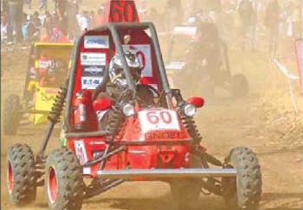

**STOP PRESS**

* An all terrain vehicle designed by students of our college which won the SAE BAJA at National Level shall be competing internationally at SAE BAJA to be held at Washington. ( Picture in box)
* Our college has been ranked amongst the topmost in survey conducted by The Tribune

COLLEGE NEWS

* A tree plantation drive to usher in the Greening of Punjab was inaugurated at the sprawling campus of Guru Nanak Dev Engineering College, Ludhiana on 14.8.2012. The enthusiasm demonstrated by the students was a real treat to watch. All this bodes well for the ecological balance which is sadly missing from the environment due to industrialization and rapid burning of fuel. The plantation drive was inaugurated by Dr. Manohar Singh Saini, Director, Guru Nanak Dev Engineering College. During the Drive all Head of Departments, Deans, senior faculty, students, staff were actively present and contributed their mite in the greening of the campus.
* Independence day was celebrated with usual fervor with the College Director unfurling the tricolor.
* Guru Nanak Dev Engineering College, Ludhiana was declared as an Autonomus College from the Academic year 2012-13 by University Grants Commission, New Delhi vide letter no. F.22/1/2012/AC dated 17.8.2012. Guru Nanak Dev Engg.College is the First Engineering College of Punjab, to be declared as an “Autonomous Engineering College” by University Grants Commission.
* The annual convocation ( first under autonomous system) was held on 3rd November,2012 wherein over 400 graduates were awarded degrees.
* The first examination under autonomous system were conducted successfully in November/December, 2012.
* Our college was declared the best by Punjab Technical University for excellent placements.
* First phase of grant under TEQIP-II was received and all departments put in their efforts to secure a successful first audit under the scheme.
* The Annual Techno Cultural Fest of the college GENESIS’13 was organized on 28th Feb-1st March, 2013. The chief guest for opening ceremony was S.T.S. Mangat, trustee, NSET, Ludhiana. Students of all streams participated in large numbers in technical as well cultural events. Renowned folk singer Sartaj graced the stage on day 1 of the function. Students showcased their talent in music, arts and technical activities. A musical evening was organized on day 2 of the function.

CIVIL ENGINEERING DEPARTMENT

**International Workshop Organized:**

One day International Workshop “Reinforced Soil and Geosynthetic Engineering” was Organised by Civil Engineering Department on 16th December, 2012 in association with Indian Geotechnical Society-Ludhiana Chapter, Discipline of Civil Engineering, Edith Cowan University Australia, Testing & Consultancy Cell, Guru Nanak Dev Engineering College.

Following topics were covered and deliberated in the workshop:

a) Soil Reinforcement –Fundamentals and Some field applications

b) Geosynthetics – Types and Functions

c) Geosynthetics–Evaluation of properties

d) Geosynthetics–Evaluation of properties

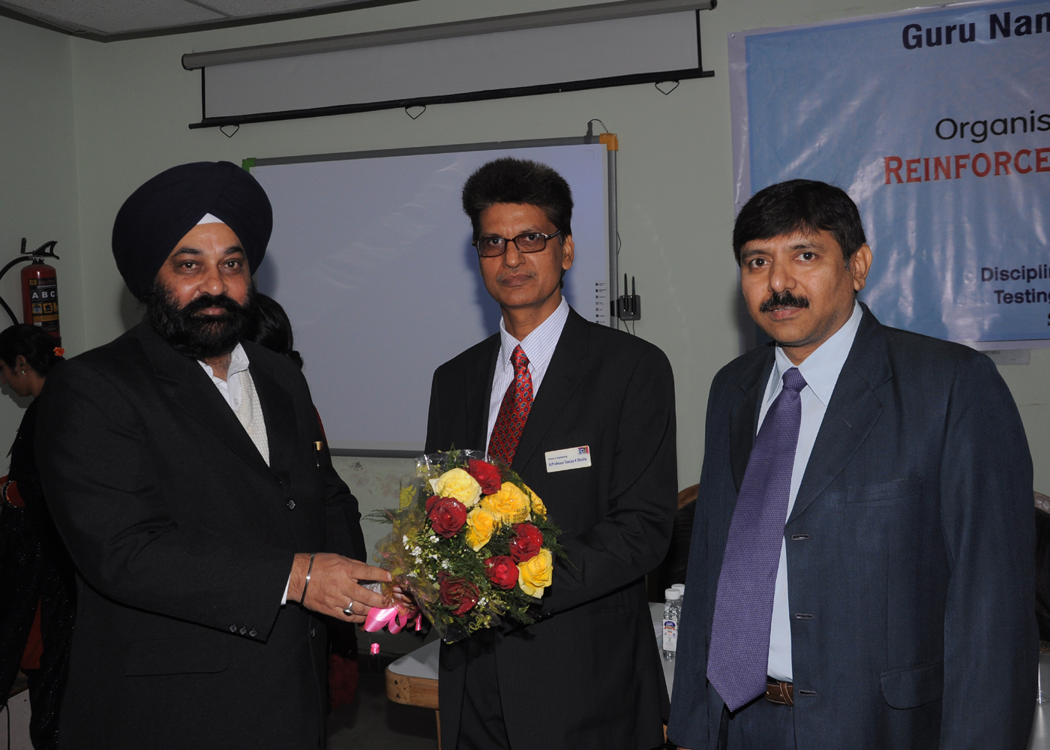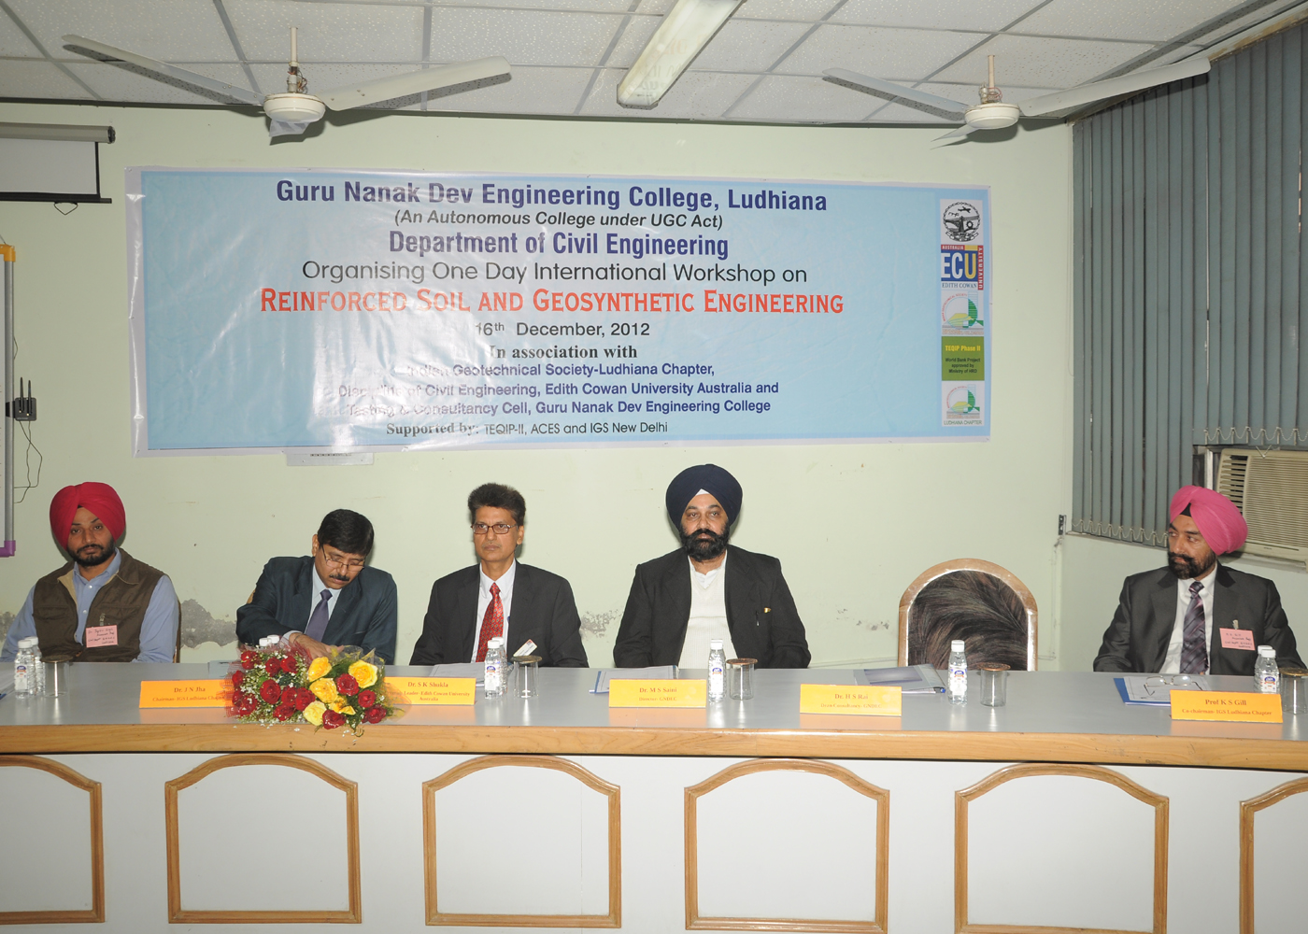

**Achievements of Department:**

* Dr. J.N.Jha was one of the Reviewer of **"GeoCongress-2013 - Stability and Performance of Slopes and Embankments III"**  organised by American Society of Civil Engineers **(ASCE),** San Diego, California
* Dr. J.N.Jha was one of the Reviever of**" Indian Geotechnical Conference- 2012"  at IIT Delhi**
* Dr. J.N.Jha Chaired the Session  for the theme**" New Developments in Computational Geomechanics" of Indian Geotechnical Conference (IGC), N. Delhi, 13- 15 Dec. 2012,**
* Dr. J.N.Jha and Dr. B.S.walia presented the paper in **Indian Geotechnical Conference held at IIT Delhi**

**Publications in Journal**

1. K.S.Gill, J.N.Jha*, A.K.Choudhary and S.K.Shukla "Load bearing capacity of the footing resting on a reinforced flyash slope" Journal of Civil Engineering and Architecture, USA, Vol.6, No. 5, 2012, PP 627-632

**Publications in Conference**

1. Gill,K.S.,Choudhary, A.K., Jha, J.N. and Shukla, S.K."Load bearing capacity of a footing resting on the reinforced fly ash slope" Indian Geotechnical Conference, Delhi, 13-15, Dec. 2012, Vol II pp 664-667
2. Choudhary, A.K., Gill,K.S., Jha, J.N. and Shukla, S.K. "Improvement in CBR of the expansive soil subgrades with a single  reinforcement layer" Indian Geotechnical Conference, Delhi, 13-15, Dec. 2012,, pp 289-292
3. Shukla, S.K.,  Jha, J.N., Gill,K.S. and Choudhary, A.K." Estimation of field compaction parameters"  Indian Geotechnical Conference, Delhi, 13-15, Dec. 2012, Vol. II, pp 668-671
4. Singh, K., Jha, J.N., Singh, H., Garg, P.,"An innovative procedure for proportioning piled strip foundation system"  Indian Geotechnical Conference, Delhi, 13-15, Dec. 2012, Vol. II, pp 564-567
5. Walia, B.S., Singh, Gurdeepak, “ Study of bearing capacity of deep foundations on flyash filled land” Indian Geotechnical Conference, Delhi, 13-15, Dec. 2012, Vol. I, pp 818-819
6. Singh, Narinder, Singh, Bikramjit, Singh, Harvinder, Gill, K.S., ”Bearing capacity behaviour of strip footing on steel reinforced flyash with its vertical cut in Laboratory” Indian Geotechnical Conference, Delhi, 13-15, Dec. 2012, Vol. I, pp 604-607.

COMPUTER SCIENCE DEPARTMENT

The following publications were made by faculty of the department:

**International Journals:**

1. Vivek Thapar, “Deployment Strategy of Homogeneous and Heterogeneous Wireless Sensor Network”, International Journal of Computer Science and Communication Engineering,pp:68-71.
2. Sukhjit Singh Sehra, Sumeet Kaur Sehra, “AI Based Model for Software Project Planning”,.International Journal of Computers & Technology, ISSN 2277–3061, pp:506-510.
3. Sukhjit Singh Sehra, Sumeet Kaur Sehra,” Conceptual Translation as a part of Gene Expression” International Journal of Computers & Technology, ISSN 2277–3061, pp 503-505.
4. Poonmadeep Kaur and Dr. Dinesh Grover, “Computer Based Payroll System Implementation For E-Governance at Punjab Agricultural University”, International Journal of Engineering Research and Development e-ISSN: 2278-067XPP. 55-60.

**International Conference:**

Parminder Singh, Associate Professor in the Department of Computer Science and Engineering demonstrated his research work on the development of a Text-to-Speech Synthesis system for Punjabi language at 24th International Conference on Computational Linguistics (COLING-2012), a very prestigious conference in the field of computational linguistics, held first time in India at IIT Bombay, Mumbai from 8th to 15th Dec., 2012. The system was well appreciated by the large number of participants from different countries from all over globe. This general purpose system is developed for Punjabi language for the first time, especially as a helping tool for visually impaired and persons with cognitive disability. This project is funded by Department of Science & Technology, Govt. of India.

**National Conferences:**

Sumeet Kaur Sehra , Lavleen Kambow, “Comparative Analysis of Software Metrics of State Chart Diagrams Using Program Slicing”, IEEE Conference on Cognizance of Applied Engineering & Research, ICAER 2012

**Expert Talks:**

Sukhjit Singh Sehra delivered expert talk on “Advanced Concepts of Computer Architecture “ at RBIEBT, Kharar, Punjab on October, 2012.

ELECTRICAL ENGINEERING DEPARTMENT

Er.Arvind Dhingra presented paper at Third International Conference on Power Electronics and Instrumentation engineering, PEIE,2012 held at Bengaluru. The paper was published in Springer Journal.

Er.Arvind Dhingra delivered an expert lecture on Marketing for Small Entrepreneurs at Lovely Professional University, Phagwara under Entrepreneurship camp organized by NITCON at LPU on 26th September,2012.

Er.Arvind Dhingra delivered an expert lecture to Faculty members of Desh Bahagt Universe on Surviving in competitive markets during an FDP , March, 2013

Er.Arvind Dhingra secured the first rank at the regional level for ISTE Ramanujam Maths Test.

ELECTRONICS AND COMMUNICATION ENGINEERING DEPARTMENT

The department organized Third National Conference RAECT-13(Recent advances in Electronics and Communication Technologies-13) sponsored by TEQIP, DST, Testing and Consultancy Cell (GNDEC).

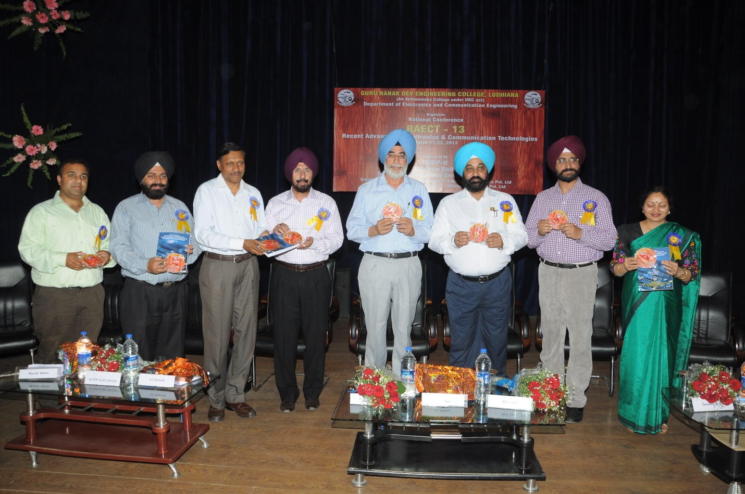

* Prof Balwinder Singh Dhaliwal attended A National Symposium on “**Antenna and Propagation**” at Cochin University, Cochin (Kerala) from 17.12.2012 to 19.12.2012
* Pf.Navneet Kaur has been awarded with gold medal for being the topper in M.Tech-ECE(2009-2011 batch) by PTU, Jalandhar
* IETE student forum and Electronics & Communication department, GNDEC Ludhiana has organized e-Vision on 18.10.2012 for Electronics & Communication department students. In this technical activity, 22 papers on latest technologies have presented by various students of B-Tech second (10), third (10) and final year (02). The 1st, 2nd and 3rd position holders were awarded with trophies and certificates. Participation certificate were given to every participant. The lists of winners are:

4th year : Harmandeep Kaur & Manpreet Kaur

3rd year : (1) Shikha & Avinashi got first position

(2) Alisha Maheshwari & Navnoor Dhiman got second position

(3) Sandeep Kaur Deol got third position

2nd Year: (1) Kushagra Mittal &Rahul Kumar got first position

(2) Manvir Singh & Birdevinder Singh got second position

(3) Samjot Kaur & Apurva Mahajan got third position

INFORMATION TECHNOLOGY DEPARTMENT

The faculty members of the department presented the technical papers as:

**International Journals:**

1. Kiran Jyoti Published paper titled “*Predicting* *the future of car manufacturing industry using Naïve Bayse Classifier*” in International Journal for Science and Emerging Technologies with Latest Trends, ISSN No. (Online) : 2250-3641, Vol. 4 No. 1 pp 25-34.

2. Kiran Jyoti published paper titled *“An Analysis of Heart Disease Prediction using  
 Different Data Mining Techniques*”,International Journal of Engineering Research &   
 Technology (IJERT), ISSN: 2278-0181, Vol. 1 Issue 8, pp 1-4.

**International Conference:**

1.Pankaj Bhambri published a paper titled “ *Development of phylogenetic tree based on   
 Kimra method”* in ICET International Conference at JUIT, Solan held on 6-8 Dec. 2012.

**Workshop Attended:**

Akshay Girdhar attended One Day Workshop related to “NTPL” organised by GNDEC, Ludhiana on 9th Jan. 2013.

**Expert Lectures**

Parminder Kaur Wadwa delivered an Expert Lecture on the topic “*Information   
 Management* “ in the seminar entitled as “ New Age Internet Technologies &   
 Applications” on 20th Dec, 2012 at GGNIMT, Ludhiana.

MECHANICAL ENGINEERING DEPARTMENT

Dr. Paramjit Singh Bilga of the department appointed as first Controller of Examinations (COE) of Guru Nanak Dev Engineering College, Ludhiana.

The following expert Lectures were delivered:

1. By Dr. Sehijpal Singh
2. On “Micro Material Removal Technologies” in faculty development programme on “Emerging trends in Mech. Engg. & Research” held at Amritsar College of Engg. & Technology sponsored by PTU, Jalandhar during 31st December, 2012 to 4th January, 2013.
3. On “Non Conventional Manufacturing” in INSPIRE at A. S. College, khanna sponsored by DST, New Delhi during 22 – 26th December, 2012.
4. On “Waste Reduction by Operation Management” in world standard day – 2012 on 15/10/2012 organised by Bureau of Indian Standards, Chandigarh.
5. By Dr. Parmjit Singh Bilga
6. On “Renewable energy system with special reference to solar refrigeration” in short term training course (21/08/2012 to 25/08/2012) on “Green Technologies for Combating Climate and Sustainable Development” on 21/08/2012 held at G. B. Pant University of Agriculture and Technology, Pant Nagar.
7. On “Solid absorption Solar Cooling” in short term training course (18/07/2012 to 21/07/2012) on “Renewable Energy Technology Specially Solar” on 20/07/2012 held at Alternative Hydro Energy Centre, I.I.T. , Roorkee.

**Paper Published in International Journals:**

Following papers were published by faculty at international level

1. Singh Harmeet, Saini R.P., Saini J.S., “Performance of a Packed bed Solar Energy Storage System Having Large Sized Elements with Low Void Fraction”, Solar Energy, 87, pp.22-34, 2013.
2. Singh Ravi Inder, Brink Anders and Hupa Mikko, “CFD modelling to study fluidized bed combustion and gasification”, Applied Thermal Engineering, Science direct, 2012, In Press, Accepted for publication,DOI:10.1016/j.applthermaleng.2012.12.017{In press}

**International Conference attended:**

1. Prem Singh attended the International Conference on Mechanical and Industrial Engineering (ICMIE-13) and presented a paper entitled “Performance Evaluation of Micro-stepped Solar Still” held at Bhubaneswar, Orissa on 27th January, 2013.
2. Gurinder Singh Brar attended the International Conference on Mechanical and Industrial Engineering (ICMIE-13) and presented a paper entitled “Finite Element Simulation of Residual Stress in Butt Welding of Two AISI 304 Stainless Steel Plates” held at Bhubaneswar, Orissa on 27th January, 2013.

**National Conference attended**:

1. Prem Singh attended the National Conference on Advances in Mechanical Engineers (AIM-2012) and presented a paper entitled “Simulation and Comparative evaluation of single basin solar still and micro-stepped solar still” at Hydrabad, 11-12 October, 2012 Under TEQUIP-II.
2. Gurinder Singh Brar attended the National Conference on Advances in Mechanical Engineers (AIM-2012) and presented a paper entitled “Dry Electric Discharge Machining – A green Environment Friendly EDM Technology ” at Hydrabad, 11-12 October, 2012 Under TEQUIP-II.

**M. Tech. Completed:**

Pawandeep Singh Grewal has completed M. Tech in Production Engineering.

**Paper Published in International Conference**:

1. Jagdeep Singh, Jatinder Kapoor and Prem Singh, “Technology Assessment and Improvement in Forging Process” International Conference on Advancements in Engineering and Technology at Sangrur, 12-13 October, 2012, pp 75-79. ISBN: 978-93-82062-66-0
2. Chatwant Singh Pandher and Rupinder Singh, “Effect of Input Parameters on Dimensional Accuracy with Different Pattern Shapes in Vacuum Moulding Technology” International Conference on Advancements in Engineering and Technology at Sangrur, 12-13 October, 2012, pp 106-107. ISBN: 978-93-82062-66-0
3. Iqbal Singh, Niraj Bala and J. S. Dureja, “Introduction to the nano structured materials and its relevance as coating material deposited by thermal spray technique” International Conference on Advancements and Futuristic Trends in Mechanical and Materials Engineering at PTU, Jalandhar, 5 -7 October, 2012, pp 443-449.

TRAINING AND PLACEMENT CELL

**T&P Cell`s initiative of career counseling for school students:**

We at G.N.D.E.C, Ludhiana are taking a step forward for the well being and to make sure that the youth of Ludhiana peruses the best career possible. A collaborated effort from our staff members and students has formulated an idea to provide a platform to discuss various career options after matriculation and pre-university level.

**ON CAMPUS placement drives**

|  |  |  |
| --- | --- | --- |
| **S.NO.** | **COMPANY** | **NO. OF STUDENTS PLACED** |
| 1 | THERMAX LTD. | 2 |
| 2 | ALFA LAVAL INDIA LTD. | 6 |
| 3 | TATA CONSULTANCY SERVICES | 50 |
| 4 | HCL (BPO) | 15 |
| 5 | ITC LTD. | 1 |
| 6 | ACC CONCRETE | 2 |
| 7 | SHAPOORJI PALLONJI & Co. LTD | 7 |
| 8 | TIT INFOTECH | 6 |
| 9 | ABACA SYSTEMS | 1 |
| 10 | OIT | 6 |
| 11 | TRIDENT GROUP | 1 |
| 12 | SEL | 9 |
| 13 | INDIAN ARMY | 28 |
| 14 | EASTMAN IMPLEX | 3 |
| 15 | DENSO, Haryana |  |
| 16 | MONDELEZ INTERNATIONAL (CADBURY) |  |
| 17 | EXL Infotech , Indore |  |
| 18 | HDFC Life |  |
| 19 | Avaptech Solutions |  |
| 20 | L&T Constructions |  |
| 21 | GVK Power |  |
| 22 | Shakunt Enterprise |  |
| 23 | C.S. Power |  |

**Joint Campus Placement**

|  |  |
| --- | --- |
| **S.No.** | **Company** |
| 1 | INNOXAPPS |
| 2 | GLOBAL PHONE NETWORKS |
| 3 | UNISYS |
| 4 | UNITED SPIRITS |
| 5 | MICROSOFT ,BANGLORE |
| 6 | GIDGI CULT |
| 7 | THOUGHTWORKS TECHNOLOGY |
| 8 | INTEGRATED TECH RESOURCES |
| 9 | NAGARRO |
| 10 | VOLVO EICHER |
| 11 | FMC TECHNOLOGIES |
| 12 | NIIT TECHNOLOGIES |
| 13 | SONA GROUJARO EDUCATIONS |
| 14 | XL DYNAMICS INDIA PVT. LTD. |
| 15 | REBUS CODE |
| 16 | TECH MAHINDRA |
| 17 | YOGAAN TECHNOLOGIES |
| 18 | INTERGLOBAL TECHNOLOGIES |
| 19 | FRANCONNECT INDIA |
| 20 | GODREJ |
| 21 | ITECH VARDHMAN |

**Seminars:**

|  |  |
| --- | --- |
| 1 | PT Education |
| 2 | Aspiring Minds |
| 3 | TIME Ludhiana |
| 4 | MAHINDRA institute |
| 5 | GTECH Software |
| 6 | Security Guru |
| 7 | Ethical Guru |
| 8 | I.M.S ludhiana |
| 9 | Grooming session by Dr. TS. Anand |
| 10 | Conjonix Himachal Wire Grp. |
| 11 | CETA infotech Pvt. Ltd. |
| 12 | Abhimanyu Group |
| 13 | Netmax technologies |

**The other events included:**

* Mock test by Bulls eye
* Aptitude test by TCY
* Aptitude test by E.Nest Technologies
* Aptitude test by Smartwiz Technologies

**Award of Honor for Best College with Excellent Job Avenues:**

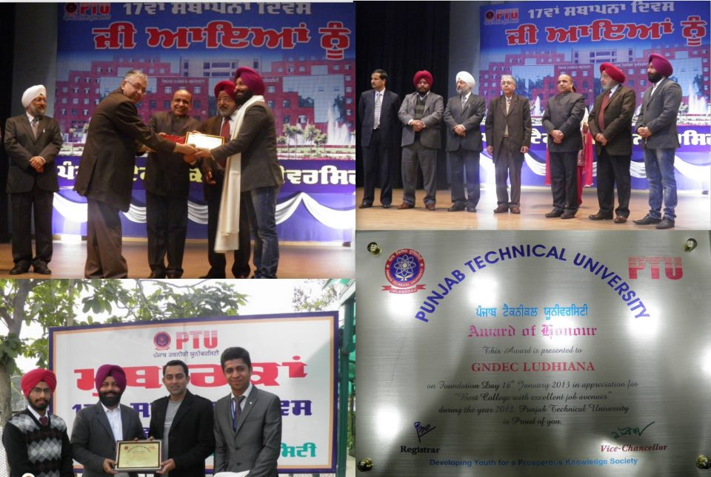The Training and Placement Cell received the Award of Honor for "Best College with Excellent Job Avenues". This award has been given on 17th Foundation Day of Punjab Technical University, Kapurthala, celebrated on 16.0.2013. This is the second consecutive year that the Training And Placement cell has received this award. The GNDEC got this award after leaving behind 400 PTU Affiliated Colleges

**STIPEND TRAINING BY MAJESTIC AUTOS**

Majestic Auto Ltd conducted recruitment drive on 18th March,2013 for 6 months industrial training with stipend of Rs 2530/- for the students of Mechanical, Electrical, Computer science and Information Technology engineering students at GNDEC, Ludhiana. More than 100 students from all over Punjab and top colleges of PTU like GIMET Amritsar, MIMIT Malout etc. appeared for the same. The process began with an aptitude test conducted to discover the technical and IQ Level of students and then the shortlisted candidates appeared for Personal Interviews by highly efficient HR team. In total 12 students were selected.

Prof. K.S Mann, Dean Training & Placement Cell, informed that each year the students of Guru Nanak Dev Engineering College perform well in various companies and organizations to uphold the past glorious traditions. Dr. M.S. Saini, Director G.N.D.E.C. thanked the representatives of the company for visiting the campus for recruitment. He complimented the team of Training & Placement Cell for keeping alive the traditions set by its predecessors.

SPORTS DEPARTMENT

The annual sports day was celebrated with usual fanfare. The college athletes participated with usual fanfare. The overall trophy was